Feature Image: Turn your passion into a profession—learn more now!

Title: How a Houston Cosmetology Program Prepares You for the Real World
Focus Keyword: Houston Cosmetology Program

Secondary Keywords:

- Beauty Training School in Houston, TX
- cosmetology
- nail tech
- esthetician
- lash tech

Internal links:

Cosmetology: https://imageacademy.org/courses/
Cosmetology School Houston: https://imageacademy.org/cosmetology/

Make this URL after Domain: real-world-training-houston-cosmetology-program

Make Meta Description.

Learn how the Houston Cosmetology Program at Image Academy trains students to get hands on skills in hair, skin, nails and lashes.
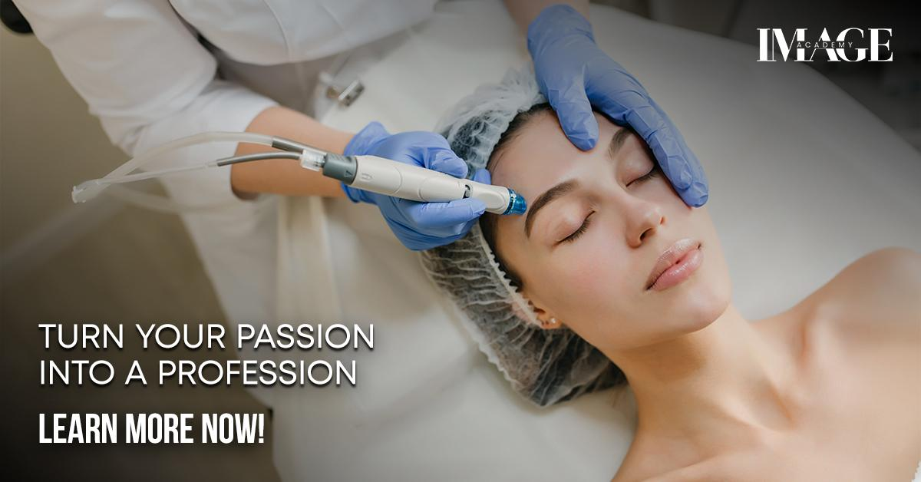

How a Houston Cosmetology Program Prepares You for the Real World H1
If you want to work in beauty, the Houston Cosmetology Program is a great place to start. At Image Academy, you can learn about our makeup, skincare and more. This program helps students learn everything step by step. You don’t need to know anything before joining. Teachers help you grow your skills. They make learning fun and easy. You also learn how to talk to clients and make them happy. When you finish you will feel ready to work in any salon. Want to know How a Houston Cosmetology Program Prepares You for the Real World? The image academy teaches you just that.
Let's get started!

Beauty Training School in Houston, TX H2
Image Academy is a top beauty training school in Houston. We train students how to cut hair, apply makeup and care for skin. It also shows how to work with clients. You learn by doing things, not just reading. That makes it easier to remember. You get real practice using real tools. Students love that they feel supported. Teachers are kind and answer questions. This makes learning fun and not difficult. You learn fast when you enjoy it. This Cosmetology School Houston is perfect for students who want real world experience.

How Cosmetology Training Builds Real Skills H2
The Houston Cosmetology Program teaches real skills. These are skills you use in real salons. You learn how to wash, cut and color hair. You learn how to do makeup for special events. You even learn about skincare.
Students practice on the model first. Then they work with real people. This builds confidence. Teachers help you at every step and show you how to be clean and safe. Hygiene is very important in beauty work.
By the end of the program, students feel ready to get jobs. They can show off what they have learned at salons. They have real experience to talk about in job interviews.

Nail Tech Training in Houston H2
Do you love nails? The Houston Cosmetology Program also teaches nail tech skills. You learn how to clean, shape and paint nails. You also learn how to do nail art and put on acrylic nails. You can try new designs and colors. You also learn how to keep nails healthy and clean. Clients love nice nails, and you’ll be able to give them that. The nail tech lessons help students get jobs in nail salons. Many even start their own business and its a good way to make money.

Learn to Be an Esthetician H2
An esthetician is someone who helps people take care of their skin. In the Houston Cosmetology Program, students learn how to clean, treat and care for skin. You learn how to do facials and use safe skin products. You also learn how to spot skin problems and help clients choose the right care. You learn about masks, scrubs and creams. Teachers show how to use the tools properly. Being an esthetician is a good job. People always want clear skin. You can start your own skincare service.

Become a Lash Tech in Houston H2
Lash techs are very popular. They help people get longer and fuller eyelashes. The Houston Cosmetology Program teaches how to apply lash extensions safely. You learn how to pick the right lashes for each person. Its fun to see the change lashes make and clients love how they look. The program shows how to clean tools and protect the eyes. Safety is very important with lashes. You can make good money as a lash tech. Some students even open their own lash studio. Others work in beauty salons as well.

Why Real Practice is Important H2
Image Academy gives students real practice. You don’t just watch videos. You try the tools and do the work. You get feedback and learn from mistakes. Real practice helps you feel ready for real clients. You learn how to talk to people. You learn how to listen and give them what they want. You also learn how to handle busy days and stay calm. This kind of practice makes a big difference. When you leave the program, you have learned many things and are sure of yourself.

Support from Teachers and Staff H3
The teachers at Image Academy are kind and care about every student. We answer your questions and help you fix mistakes. Our staff helps you feel welcome and you can talk to us if you need help. We are there to support you. When students feel comfortable, they learn better. That’s why many people love our Houston Cosmetology Program. You are never alone, we are there to guide you.

Are You Ready for Your First Job H3
After the program, students feel ready for work. They have learned how to use tools, talk to clients, and stay safe. They also have pictures of their work to show salons. Our teachers help you get ready for job interviews. With our help many students get jobs fast. Some open their own beauty business. The program gives you the skills and the support you need.

Why Choose Image Academy in Houston H3
Image Academy is a great choice for anyone who loves beauty. We offer training in hair, nails, skin and lashes. You get to learn many things in one place. Our school is clean and friendly. The tools are new. Teachers are kind. You feel like part of a team. If you live in Houston, this school is close to home. It’s easy to get there. The cost is fair and the lessons are great. Many students say its the best choice they ever made.

Conclusion: Start Your Beauty Career Today H3
If you want to start a career in beauty, choose the Houston Cosmetology Program at Image Academy. You will learn step by step. You will get real practice. And you will feel ready for the real world. Whether you want to be a nail tech, esthetician or lash tech, we can help. You will learn real skills that salons look for. Don’t wait. Your future in beauty starts now.

GMB Post
Looking for a beauty school that really prepares you for the real world? At Image Academy, our Houston Cosmetology Program is the perfect place to start your journey. We help students learn all the important beauty skills they need from cutting and coloring hair to facials, lash extensions and nail art. Whether you want to become a nail tech, esthetician, or lash tech, our training covers it all.
We are not just a beauty training school in Houston, TX we are a hands-on learning center. Our students practice with real tools and real clients.
At Image Academy, we focus on making learning fun, simple, and practical. You’ll learn how to use beauty tools safely, talk to clients and handle real work situations. When you finish the program, you will feel fully ready to work in a salon or start your own beauty business.
Join the Cosmetology School Houston students trust. Start building your future in beauty today at Image Academy.

